**SQL Practical Question**

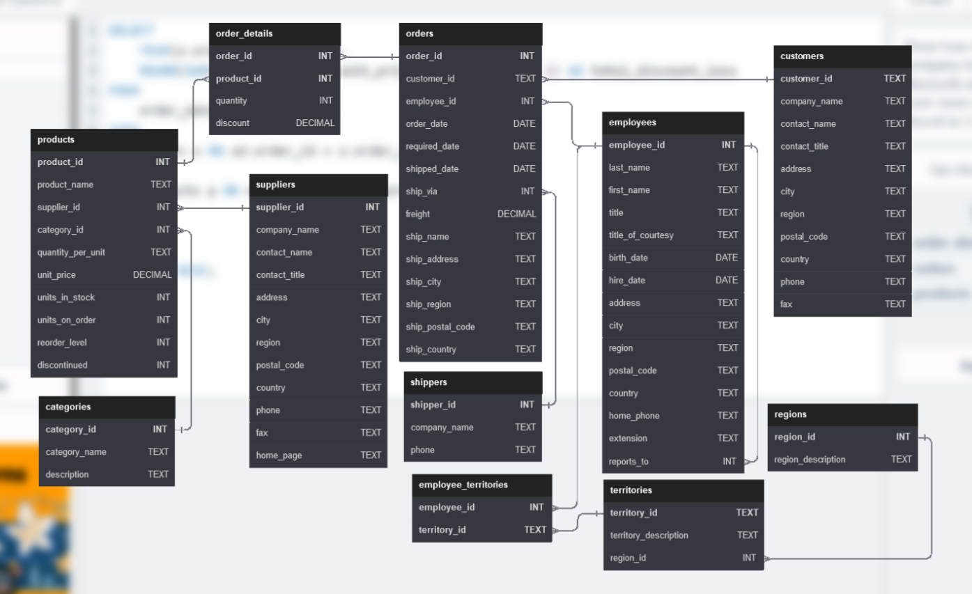

1. Show the category_name and description from the categories table sorted by category_name.

1. Show all the contact_name, address, city of all customers which are not from 'Germany', 'Mexico', 'Spain'

1. Show order_date, shipped_date, customer_id, Freight of all orders placed on 2018 Feb 26

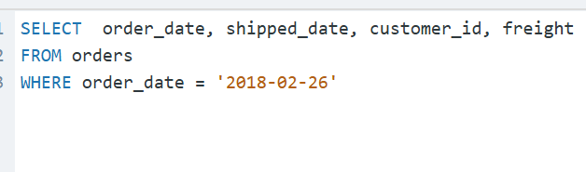

1. Show the employee_id, order_id, customer_id, required_date, shipped_date from all orders shipped later than the required date

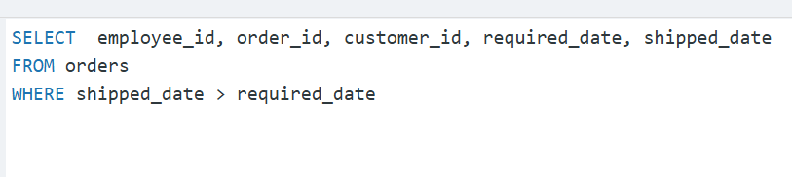

1. Show all the even numbered Order_id from the orders table

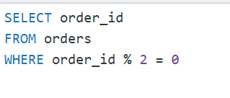

1. Show the city, company_name, contact_name of all customers from cities which contains the letter 'L' in the city name, sorted by contact_name

1. Show the company_name, contact_name, fax number of all customers that has a fax number. (not null)

1. Show the first_name, last_name. hire_date of the most recently hired employee.

9. Show the average unit price rounded to 2 decimal places, the total units in stock, total discontinued products from the products table.

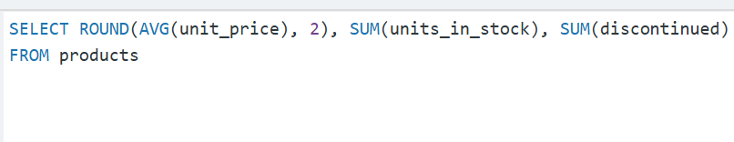

1. Show the ProductName, CompanyName, CategoryName from the products, suppliers, and categories table

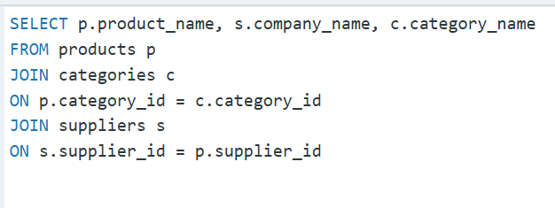

1. Show the category_name and the average product unit price for each category rounded to 2 decimal places.

1. Show the employee's first_name and last_name, a "num_orders" column with a count of the orders taken, and a column called "Shipped" that displays "On Time" if the order shipped_date is less or equal to the required_date, "Late" if the order shipped late.  
     
   Order by employee last_name, then by first_name, and then descending by number of orders.

1. Show how much money the company lost due to giving discounts each year, order the years from most recent to least recent. Round to 2 decimal places

